Bending of beams
Members that are slender and support loadings that are applied perpendicular to their longitudinal axis are called beams. Beams are considered among the most important of all structural elements. They are used to support the floor of a building, the deck of a bridge, or the wing of an aircraft. Also, the axle of an automobile, the boom of a crane, even many of the bones of the body act as beams.
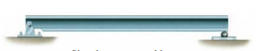  Simply supported beam | 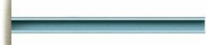  Cantilever beam
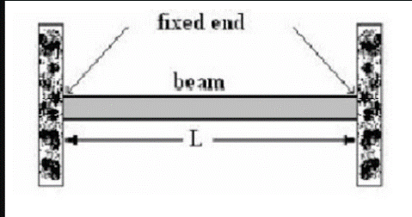  Fixed end beam | 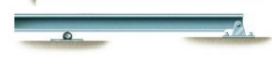  Overhanging beam
Because of the applied loadings, beams develop an internal shear force and bending moment that, in general, vary from point to point along the axis of the beam.
Sign Convention for shear force and bending moment.  Shear force is positive if it acts down ward on right section or upward on left section (rotate the section clockwise).  Bending moment is positive if it acts counter clockwise on right section or clockwise on left section (sagging moment)  (Understand the difference between static sign convention and deformation sign convention!!) |  |  | 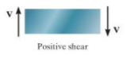  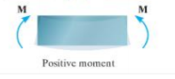
Consider a beam loaded and supported as shown.  From the equilibrium consideration of the beam,  $$X_{A}=0$$  Consider a section $PQ$ of the beam at a distance x from the left end and consider the free body diagram. |  | 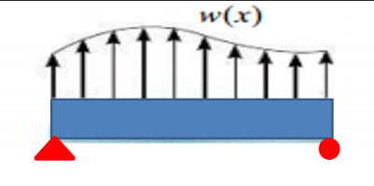  $$Q$$  $$P$$  $$R_{B}$$  $$Y_{A}$$  $$X_{A}$$
The shear force and bending moment on the left section is $V$ and $M$, and those on the right section is$V+dV$ and $M+dM$. Note the directions of the shear force and bending moment as per the sign convention. |  |  |  | $$w(x)$$  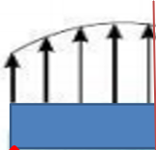  $$Q$$  $$P$$  $$V+dV$$  $$V$$  $$M$$  $$M+dM$$  $$dx$$

Writing down the equations of equilibrium,
$$ΣF_{y}=0 ≫≫V-\left(V+dV\right)+w dx=0≫≫ \frac{dV}{dx}=w$$
Algebraic sum of all moments about the perpendicular axis passing through $Q,$
$$ΣM_{Q}=0 ≫≫M+dM-M-V dx-w dx. \frac{dx}{2}=0$$
Since $dx$ is very small, the higher order terms can be neglected, hence we can write,
$$\frac{dM}{dx}=V$$
#Example 1  Draw the shear force and bending moment diagram of the beam loaded and supported as shown. | 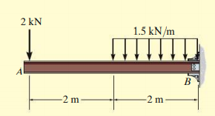  $$2 kN$$  $$2$$  $$1$$
Consider sections of the beam at $1$ and $2$( where the load changes) at distance $x$ from the free end. The shear force and bending moment on the right sections are shown according to the sign convention. | $$M_{1}$$  $$V_{1}$$  $$x$$  $$V_{2}$$  $$M_{2}$$  $$2m$$  $$x$$  $$2 kN$$
Consider the equilibrium of free body diagram 1 which is valid in the region ($0≤x≤2m$).  $$ΣF_{y}=0$$  $$-2 kN-V_{1}=0≫≫V_{1}=-2 kN \left\{\begin{matrix}x=0, V_{1}=-2 kN \\ x=2m, V_{1}=-2 kN\end{matrix}\right\}$$  The shear force remains constant in the section $0≤x≤2m$ | $$-2 kN$$  $$-2 kN$$  $$-5 kN$$  Shear force diagram
Algebraic sum of all moments about the perpendicular axis passing through the section  $$Σ{M_{1-1}}_{ }=0$$  $$M_{1}+2 kN×x=0 ≫≫M_{1}=-2x kNm\left\{\begin{matrix}x=0, M=0 kNm \\ x=2m, M=-4 kNm\end{matrix}\right\}$$  The bending moment varies $linearly$ from $0$ to $-4 kNm$ in the region $0≤x≤2m.$ | $$-4 kNm$$  $$-11 kNm$$  Bending moment diagram
Consider the equilibrium of free body diagram 2.
$$ΣF_{y}=0 ≫≫-2 kN-V_{2}-1.5\left(x-2\right)=0≫≫V_{2}=-2-1.5\left(x-2\right) kN \left\{\begin{matrix}x=2m, V=-2 kN \\ x=4m, V=-5 kN\end{matrix}\right\}$$
The shear force varies linearly from $-2 kN$ to $-5 kNm$ in the region $2m≤x≤4m.$
Algebraic sum of all moments about the perpendicular axis passing through the section
$$Σ{M_{2-2}}_{ }=0 ≫≫M_{2}+2 kN×x+1.5×\frac{{\left(x-2\right)}^{2}}{2}=0 ≫≫M_{2}=-2x-\frac{{1.5(x-2)}^{2}}{2}kNm\left\{\begin{matrix}x=2m, M=-4 kNm \\ x=4m, M=-11 kNm\end{matrix}\right\}$$
The bending moment varies parabolically from $-4 kNm$ to $-11 kNm$ in the region $2≤x≤4m.$

#Example 2  Draw the shear force and Bending moment diagram for the beam loaded and supported as shown. | 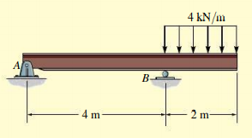  $$2m$$  $$10 kN$$
Consider the free-body diagram of the whole beam  $$ΣF_{x}=0 ≫≫X_{A}=0$$  $$ΣF_{y}=0 ≫≫Y_{A}+R_{B}-10 kN-4kN/m×2m=0$$  $$ΣM_{A}=0≫≫ R_{B}×4m-10 kN×2m-(4kN/m×2m)×5m=0$$  $$R_{B}=15 kN ≫≫Y_{A}=3 kN$$ |   $$X_{A}$$  $$Y_{A}$$  $$R_{B}$$  $$2m$$  $$10 kN$$
Section 1-1 $(0≤x≤2m)$  $$ΣF_{y}=0 ≫≫Y_{A}-V_{1}=0≫≫$$  $V_{1}=3 kN \left\{\begin{matrix}x=0, V_{1}=3 kN \\ x=2m, V_{1}=3 kN\end{matrix}\right\}$constant  $$ΣM_{1-1}=0≫ M_{1}-Y_{A}×x=0≫$$  $M_{1}=3x kNm\left\{\begin{matrix}x=0, M_{1}=0 \\ x=2m, M_{1}=6 kNm\end{matrix}\right\}$ linear |   $$V_{1}$$  $$M_{1}$$  $$Y_{A}$$  $$x$$
Section 2-2$(2m≤x≤4m)$  $$ΣF_{y}=0 ≫Y_{A}-V_{2}-10 kN=0≫$$  $V_{2}=-7 kN \left\{\begin{matrix}x=2m, V_{2}=-7 kN \\ x=4m, V_{2}=-7 kN\end{matrix}\right\}$ constant  $$ΣM_{2-2}=0≫ M_{2}-Y_{A}×x+10 kN\left(x-2\right)=0≫$$  $M_{2}=3x-10\left(x-2\right) kNm\left\{\begin{matrix}x=2m, M_{2}=6 kNm \\ x=4m, M_{2}=-8 kNm\end{matrix}\right\}$ linear |   $$Y_{A}$$  $$2m$$  $$x$$  $$V_{2}$$  $$M_{2}$$  $$10 kN$$
Section 3-3 $(4m≤x≤6m)$  $$ΣF_{y}=0 ≫Y_{A}-V_{3}-10 kN+R_{B}-4 kN/m(x-4)=0≫$$  $V_{3}=8-4(x-4)kN \left\{\begin{matrix}x=4m, V_{3}=+8 kN \\ x=6m, V_{3}=0\end{matrix}\right\}$ linear  $$ΣM_{3-3}=0≫$$  $$M_{3}-Y_{A}×x+10 kN \left(x-2\right)-R_{B}\left(x-4\right)+4kN/m×\frac{{\left(x-4\right)}^{2}}{2}=0≫$$  $$M_{3}=3x-10\left(x-2\right)+15\left(x-4\right)-{2\left(x-4\right)}^{2} kNm\left\{\begin{matrix}x=4m, M_{3}=-8 kNm \\ x=6m, M_{3}=0\end{matrix}\right\}$$  Parabolic |   $$4 kN/m$$  $$x$$  $$V_{3}$$  $$M_{3}$$  $$Y_{A}$$  $$R_{B}$$  $$2m$$  $$10 kN$$
$$8 kN$$
$$3 kN$$

$$-7 kN$$
Shear force diagram
Point of contra flexure:  Point where the bending moment changes its sign.  $$M_{2}=0≫≫≫3x-10\left(x-2\right)=0≫≫x=2.86 m$$ | $$6 kNm$$  $$x$$  $$-8 kNm$$  Bending Moment diagram

Can you draw the shear force and bending moment diagram for the beam shown below??
$$1 m$$
$$1 m$$
$$1 m$$
$$500 N$$
$$500 N$$

SFD

BMD

Exercises
Draw the shear force and bending moment diagrams of the beams shown below.
  $$120 kN/m$$ | 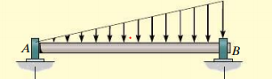  $$roller$$  $$hinge$$  $$12m$$
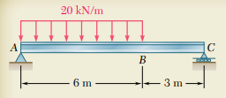  $$1.5m$$  $$10 kNm$$ | 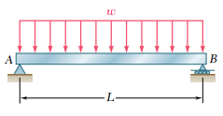
The engine crane is used to support the engine, which has a weight of $1200 lb$. Draw the shear force and bending moment diagram of the boom ABC when the boom is horizontal. $(1 lb=4.45 N, 1 ft=0.3 m)$ | 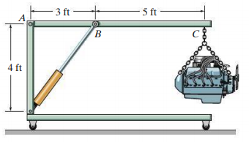

References:
- Mechanics of Materials, 2/e, J. M. Gere & S. P.Timoshenko, CBS Publishers.
- Mechanics of Materials, 6/e, F.P. Beer & E. R. Johnston, McGraw Hill
- Engineering Mechanics of Solids, 2/e, E. P. Popov, Pearson Education Asia.
- Mechanics of Materials, 9/e, R. C. Hibbeler, Prentice Hall.

